Installation and Operation Procedure
of SAMCOM Radio CPS Suite

- Installation Procedure of Program Cable Driver
Step 1: Install the driver of the program cable named ’CH341SER.EXE’ on computer by double clicking on it.
An installation dialog box appears, as shown here. Click the INSTALL button to run the installation.
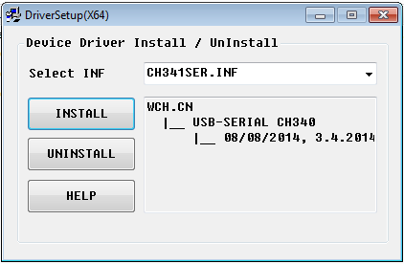

Once the installation is completed, a prompt box as below will come up, showing that the driver is successfully installed. Click the OK button to close the popup.

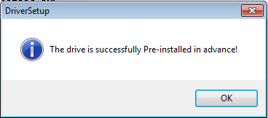

Step 2: Insert the USB plug of the program cable into one of the USB sockets of the computer.
An information prompt box as below popups on the status bar in the Taskbar of windows, indicating that the driver software is running the port configuration for the USB port which has just been plugged by a Program Cable.
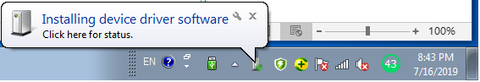

When the USB port is configured successfully, the information box on the status bar becomes the following display.
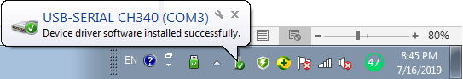

Step 3: Open the Device Manager of Windows, and find and then expand the Ports (COM & LPT) device category.
Under the Ports (COM & LPT), a virtual COM port will appear, as below in red box. Remember the number of the COM port, e.g., COM3 as below.
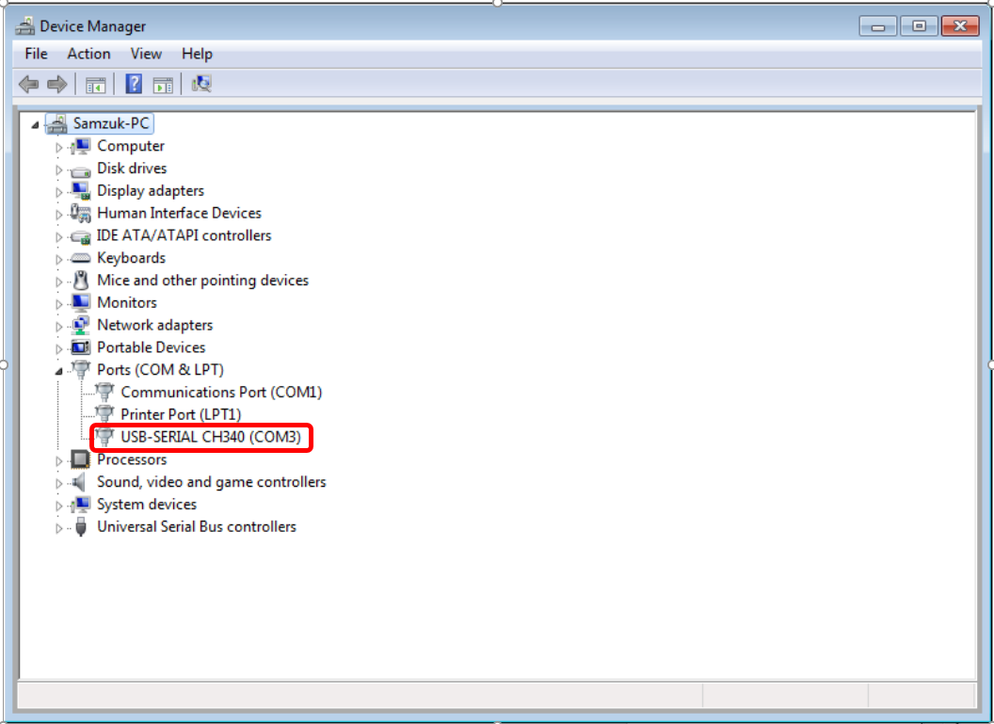

- Installation Procedure of Radio Program Software
Step 1: Double click the Radio Program Software, ‘SAMCOM_Radio 20Chn CPSV1.13setup’, to run the installation on the computer.
Step 2: Click the Next > button, as shown below.
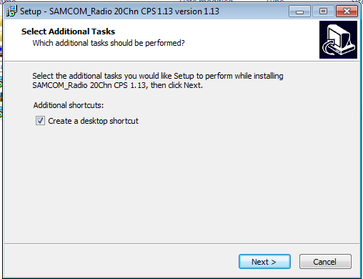

Step 3: Click the Install button.
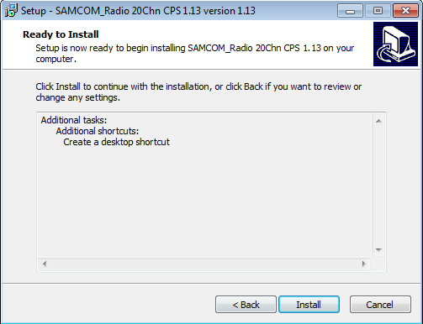

Step 4: Click the Next > button.
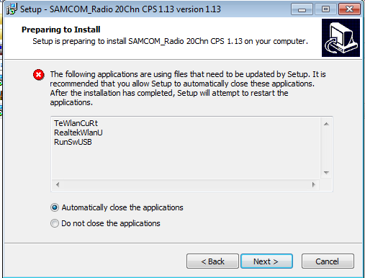

Step 5: Click the Finish button.
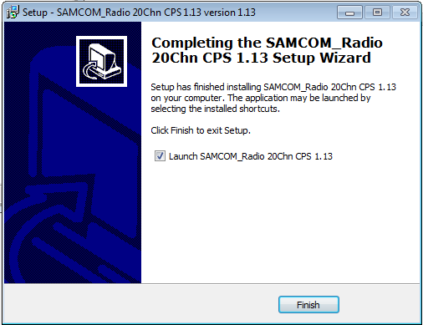

Step 6: Radio Program Software is opened automatically, as shown.
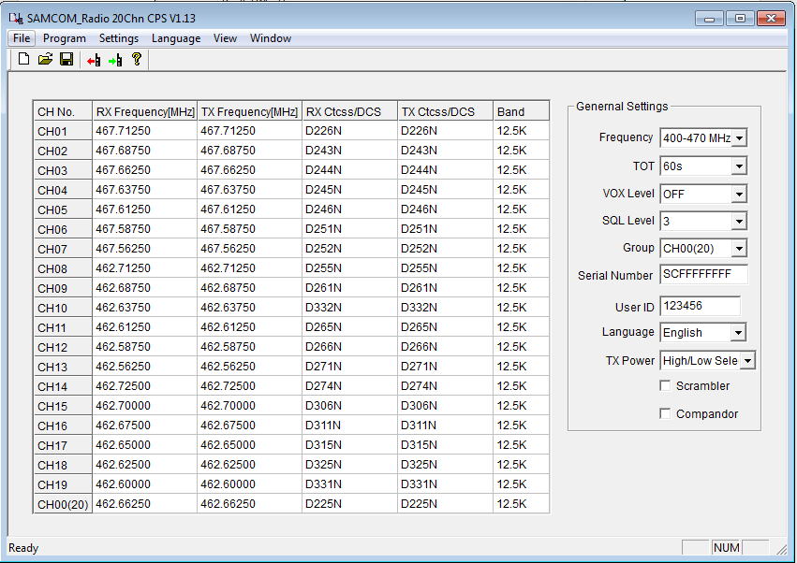

- Basic Operation of Radio Program Software
Step 1: In the interface of Radio Program Software , click the Menu Settings > Communication Port, as shown below.
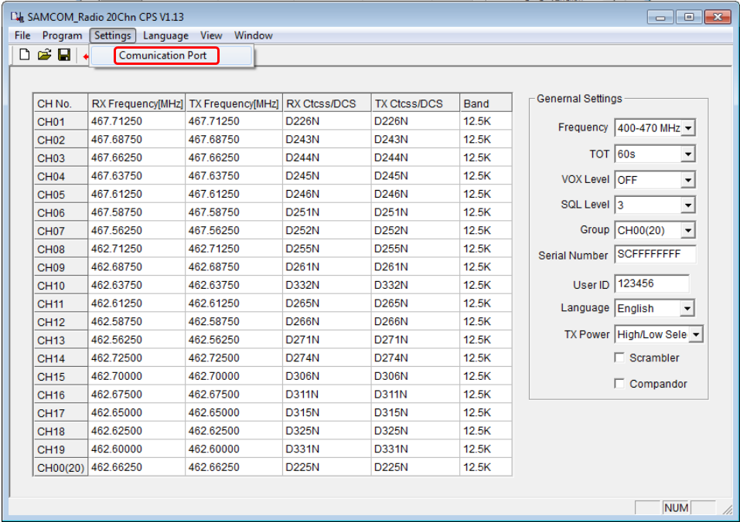

Step 2: The Port Select dialog appears, as shown below.
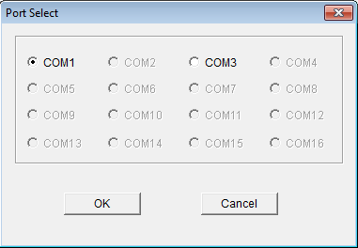

Click the check box near the COM port which just appeared under the Ports (COM & LPT) in Device Manager of Windows when the program cable is plugged in.

Click the OK button to close the box.

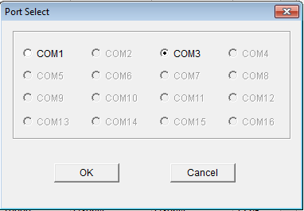

Step 3: Turn on the power of 2-way radio, and then VIGOROUSLY insert the 2-pin plug of program cable into the Audio/Program Jack of the radio.

Step 4: If you want to read the channel configuration parameters and settings of the radio, just click the icon-button on the Toolbar, and the Read dialog box appears.
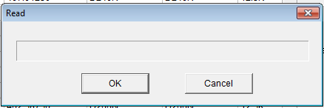

Click the OK button, and a status box appears to display Read in process..
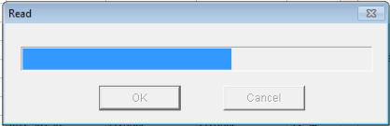

After read operation is completed, the dialog below appears, showing Read successfully. Click the OK button to close it.
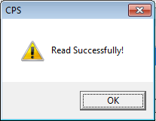

The channel configuration parameters and settings of the radio are shown in the work area of program software. Any parameters or settings can be modified, if necessary.

After completing the modification, you can write them into the radio, that is to program it.

Step 4: To program the radio, just click the icon-button on the Toolbar, and the Write dialog box appears.
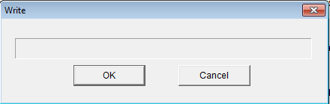

Click the OK button, and a status box appears to display Write in process.
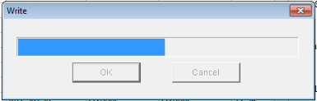

After write operation is completed, the dialog below appears, showing Program successfully. Click the OK button to close it.
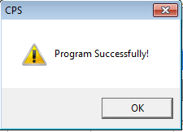

Step 5: Pull off the 2-pin plug of program cable from the radio, turn off the radio power.

——END——

